# Jenkins Automated Deployment

Jenkins provides many plugins which can be used to transfer the build files to the respective application or web server after a successful build, for example, the "**Deploy to container**" plugin. This plugin takes a war or ear file and then it deploys to a running remote application server at the end of a build.

To use this plugin, follow the given steps:

**Step 1:** Go to the manage Jenkins -> Manage Plugins. Go to the **Available** tab and filter for "**Deploy to container**" plugin.

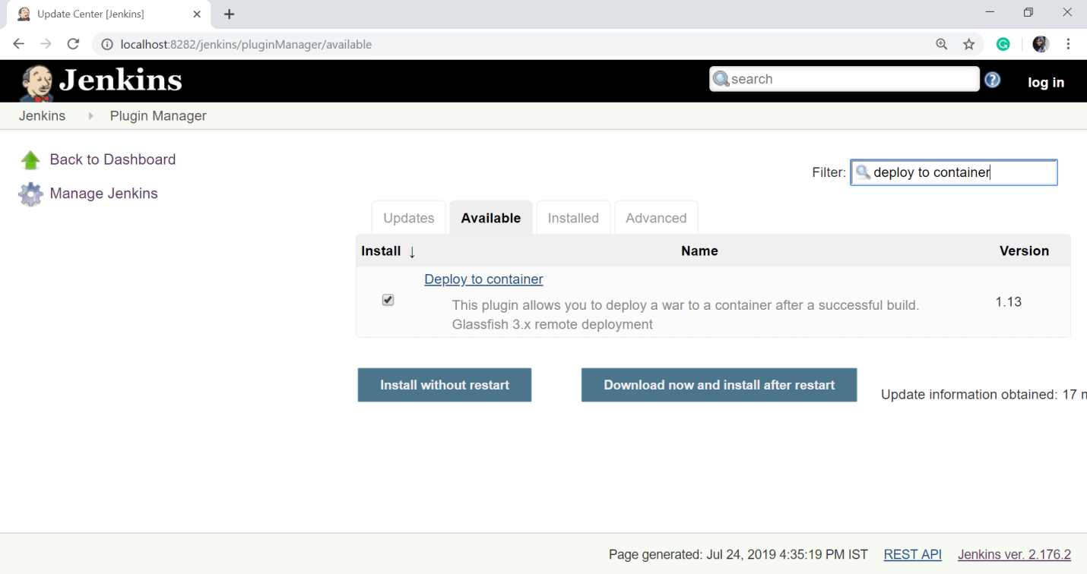  
  
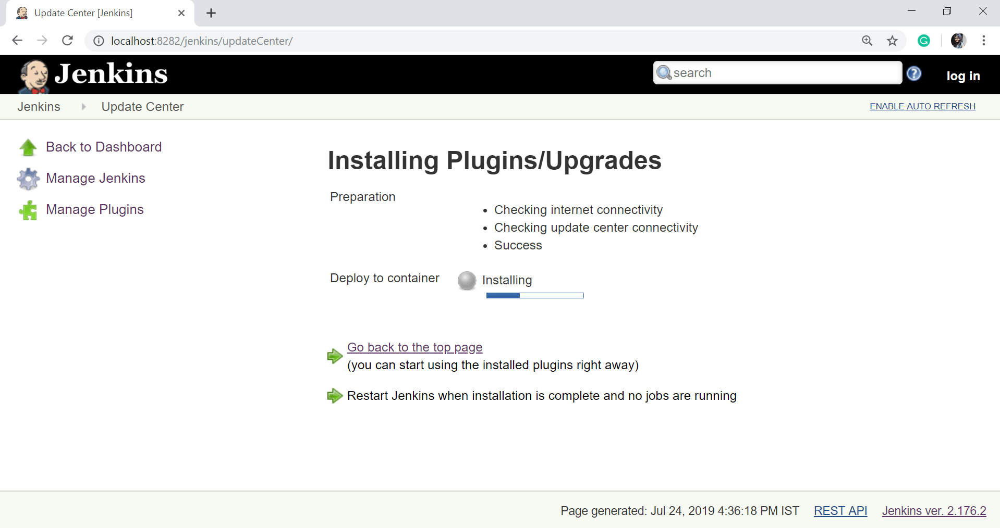

Click on **Go back to the top page**.

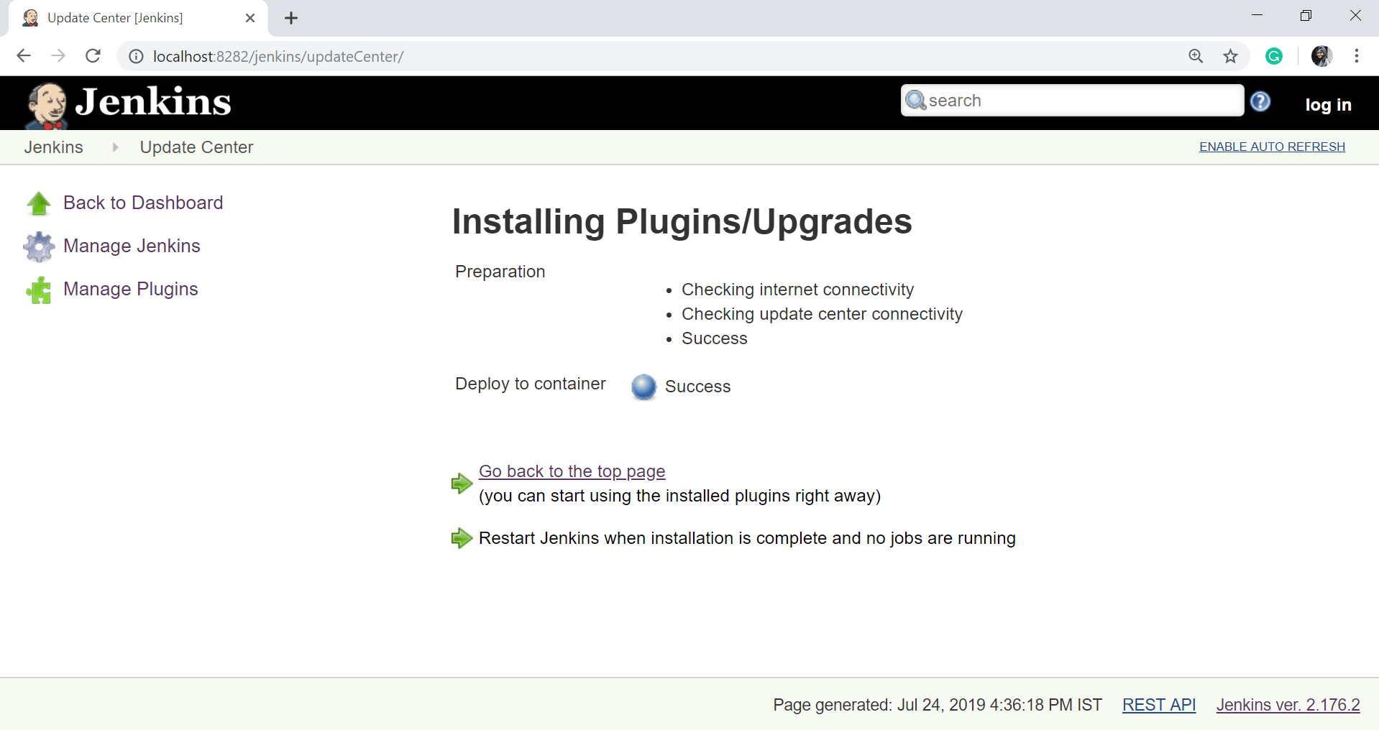

**Step 2:** Go to your created build project and click on the **Configure** option from the left-side of the panel.

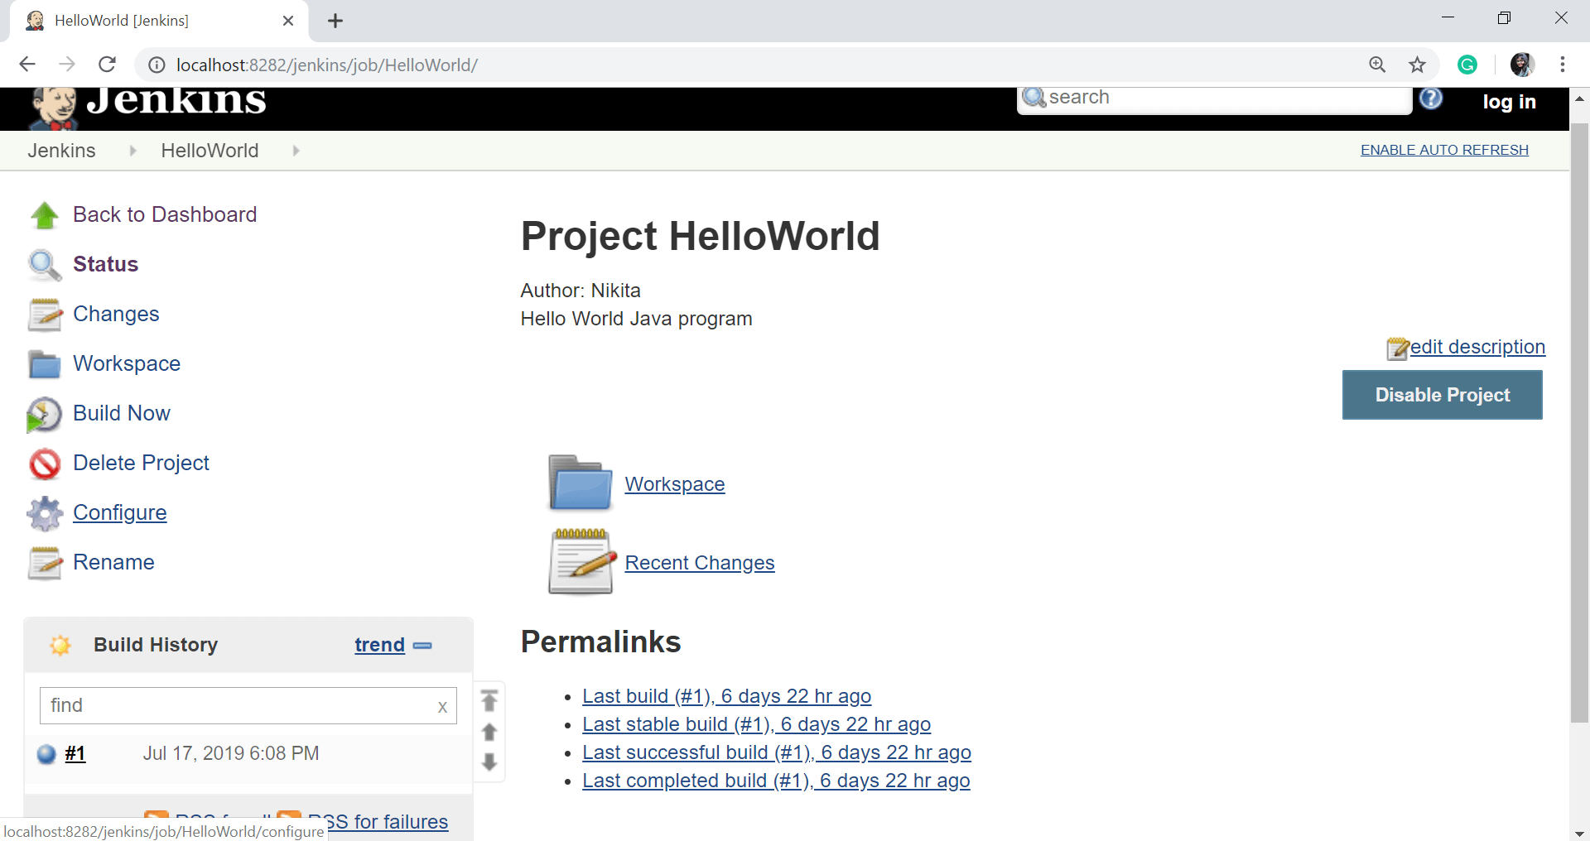

**Step 3:** On the configuration page, scroll down and click on **Add post-build action** button. Select **Deploy war/ear to a container** option.

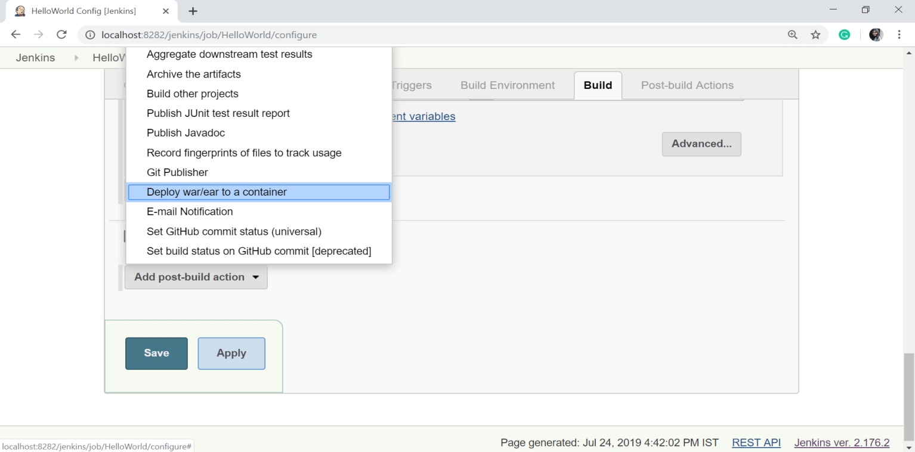

**Step 4:** In the **Deploy war/ear to a container** section, enter the information of the server on which the files need to be deployed.

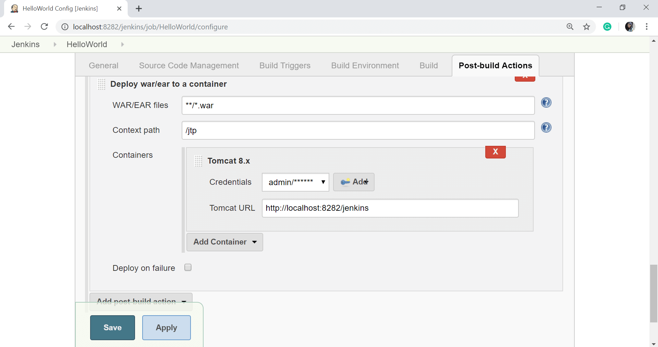

**Step 5:** Click on the **Save** button.

Now select **Build Now**.

The above steps will ensure that all the required files are deployed to the container after the successful build.